# FMX Mobile Application Development

## Lab Exercise 03.06: StyleBook and Working with Custom Styles.

FireMonkey applications automatically load and display the appropriate native style at run time (depending on the target device), without you needing to add a stylebook or any code. Also, FireMonkey applications can have **custom styles** that display well on high-resolution displays as well as standard-resolution displays. High-resolution styles (such as Retina) are only shown at run time.

## Loading Your Own Custom Styles

The Lab Exercise describes working with custom styles, such as the **Jet** style, which is available in the FireMonkey Premium Style Pack, that you can download from GetIt

<http://docwiki.embarcadero.com/RADStudio/en/Installing_a_Package_Using_GetIt_Package_Manager>

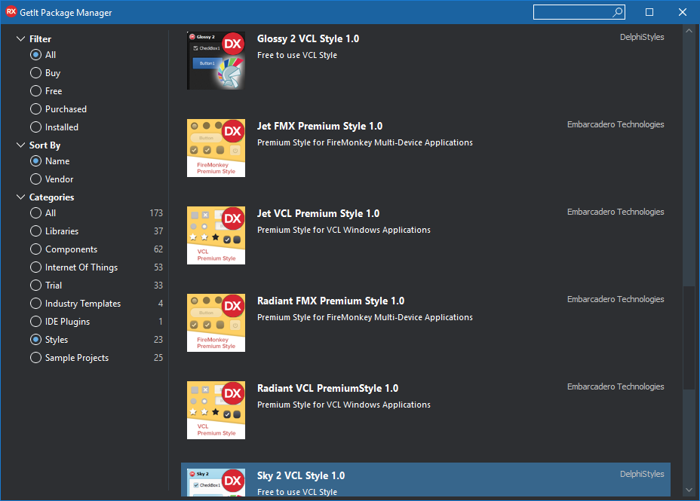

Adding a Custom Style to Your Mobile Application

RAD Studio includes the following custom mobile styles:

* **Android**:
  + AndroidDark.fsf
  + AndroidLDark.fsf
  + AndroidLDarkBlue.fsf
  + AndroidLight.fsf
  + AndroidLLight.fsf
  + GoogleGlass.fsf
* **iOS**:
  + iOSBlack.fsf
  + iOSTransparent.fsf

These styles are installed on your system, in the **Styles** directory, in the following platform-specific directories:

C:\Users\Public\Documents\Embarcadero\Studio\20.0\**Styles\iOS**

C:\Users\Public\Documents\Embarcadero\Studio\20.0\**Styles\Android**

The custom mobile styles for iOS and Android include support for standard- and high-resolution devices within one style file. This includes built-in support for:

* iOS standard, iOS Retina devices (1x, 2x) and iOS Retina HD devices (3x)
* Multiple resolutions for Android devices (1x, 1.5x, 2x, 3x)

In addition, you can get new FireMonkey styles that are available in the [FireMonkey Premium Style Pack](http://cc.embarcadero.com/item/30491), which also support 3x resolution for iOS 8 devices.

To add a custom style to a FireMonkey multi-device application

1. Create a [**Multi-Device Application**](http://docwiki.embarcadero.com/RADStudio/en/Multi-Device_Application).
2. With the **Master** view selected, add a [**TStyleBook**](http://docwiki.embarcadero.com/Libraries/en/FMX.Controls.TStyleBook) component to your form.
3. On the **Master** view, select a style from the Form Designer **Style** drop-down menu (Windows, OSX, iOS, or Android). This example uses Android style for the **Master** view:

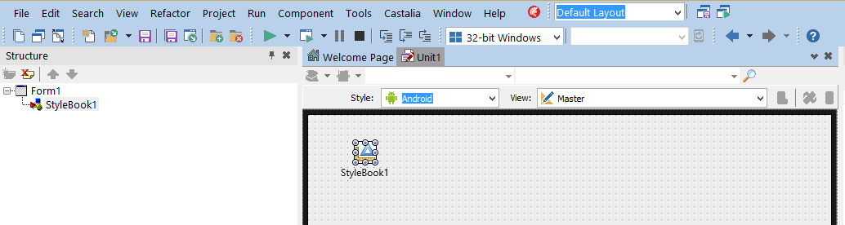

4. Load a FireMonkey style file for the appropriate platform:

* 1. Double-click the StyleBook. The [**FireMonkey Style Designer**](http://docwiki.embarcadero.com/RADStudio/en/FireMonkey_Style_Designer) opens.
  2. Click the Open Style button on the toolbar of the **FireMonkey Style Designer**.
  3. Navigate to the FireMonkey style file you want.

For example, if **Android** is the Form Designer style set for the current view, you would load and assign an Android style such as **AndroidLight.fsf**.

**Note:** The FireMonkey styles for the various Form Designer styles are located in parallel directories:

**Windows:** C:\Users\Public\Documents\Embarcadero\Studio\20.0\Styles

**Android:** C:\Users\Public\Documents\Embarcadero\Studio\20.0\Styles\Android

**iOS:** C:\Users\Public\Documents\Embarcadero\Studio\20.0\Styles\iOS

5. Switch to each of your created views, select the **TStyleBook** component in that view, and load the custom style related to that platform. When working with custom FireMonkey styles, each view, including the **Master**view, must have a style assigned in the Form Designer.

That is, load a Windows style for the "Windows Desktop" view, an Android style for the "Android..." view, a Mac style for the "OS X Desktop" view, an iOS style for the "iPad" and the "iPhone" views.

**Note:** If you have different views for iPad and iPhone, you need to load the same iOS style for each view.

6. To use the custom style instead of the native style on a form, you need to assign the stylebook you want to use to the form at design time:

* On the [StyleBook](http://docwiki.embarcadero.com/Libraries/en/FMX.Forms.TForm.StyleBook) property of the form, select the StyleBook to apply from the drop-down menu.
* **Note:** See [Using Custom Styles on Multiple Forms](http://docwiki.embarcadero.com/RADStudio/en/Working_with_Native_and_Custom_FireMonkey_Styles#Using_Custom_Styles_on_Multiple_Forms) to learn how to apply a specific custom style to multiple forms without editing the [StyleBook](http://docwiki.embarcadero.com/Libraries/en/FMX.Forms.TForm.StyleBook) property of each form.

## Using Custom Styles on Multiple Forms

To apply the same custom style to all the forms of an application, instead of doing it at design time setting the [StyleBook](http://docwiki.embarcadero.com/Libraries/en/FMX.Forms.TCommonCustomForm.StyleBook) property of each form, you can do it at run time using the [UseStyleManager](http://docwiki.embarcadero.com/Libraries/en/FMX.Controls.TStyleBook.UseStyleManager) property.

To use the same custom style on all the forms of an application.

* Place the [TStyleBook](http://docwiki.embarcadero.com/Libraries/Rio/en/FMX.Controls.TStyleBook) component on the main form.
* Set the [UseStyleManager](http://docwiki.embarcadero.com/Libraries/Rio/en/FMX.Controls.TStyleBook.UseStyleManager) property on the [Object Inspector](http://docwiki.embarcadero.com/RADStudio/en/Object_Inspector) to True
* Double-click the StyleBook to open the **FireMonkey Style Designer** and [load the style](http://docwiki.embarcadero.com/RADStudio/en/Working_with_Native_and_Custom_FireMonkey_Styles#To_add_a_custom_style_to_a_FireMonkey_multi-device_application).

## Using Custom Styles on Controls in Multiple Forms

An application may have more than one [TStyleBook](http://docwiki.embarcadero.com/Libraries/Rio/en/FMX.Controls.TStyleBook) object, then different forms may use the [StyleBook](http://docwiki.embarcadero.com/Libraries/Rio/en/FMX.Forms.TForm.StyleBook) property to reference any of these stylebooks, one at a time. Notice that controls in any form can always use the [StyleLookup](http://docwiki.embarcadero.com/Libraries/Rio/en/FMX.Controls.TStyledControl.StyleLookup) property to specify any custom style defined in any [TStyleBook](http://docwiki.embarcadero.com/Libraries/Rio/en/FMX.Controls.TStyleBook) object used in the current project group.